MED D - Delayed Prescriber Response/Prescriber Hold Process

Overview
Prescriber Indefinite Hold
Prescriber Hold Until
Inbound Call from Prescriber
Log Activity
Resolution Time
Related Documents

Description: This document provides information regarding the Delayed Prescriber Response process.

Overview
The Delayed Prescriber Response process involves the handling of incomplete prescriptions that require clarification from the prescriber.

Note: It may also be used if the beneficiary contacts us indicating the prescriber provided a response, but there is no record of the contact.

There are two types of Delayed Prescriber Response Hold:
- Prescriber Hold Until - The prescriber is expected to respond by a certain date. For example, the prescriber is on vacation, but will respond within one week
- Prescriber Indefinite Hold - The future response date is unknown. For example, we may hear back from the prescriber several days after the prescription is placed on hold, or it might be weeks until a response is received.

Prescriptions are placed on Prescriber Hold due to delay in response by the prescriber, not due to any error made by CVS Caremark. Also, note that these prescriptions are incomplete and not yet valid. As a result, they will not be eligible for:
- Bridge Supply
- Transfers to other pharmacies

For more information about how we contact prescribers for new prescriptions, refer to Obtaining a New Prescription for the Member.

Note: Although similar to Participant Hold and Caremark Hold functionality, CCRs are unable to release prescriptions held due to delayed prescriber response. Only the pharmacy has this capability.
- Participant Hold offers the ability to place a prescription on hold until the beneficiary requires it and PBM Hold offers the ability to place a prescription on hold when circumstances prevent it from being filled.

Prescriptions placed on Prescriber Hold will not be RTP’d to the beneficiary. As a result of the order being placed on hold, communication is made to the beneficiary based on their CMP messaging preference (automated call, text or email). Via this messaging, the beneficiary is informed of the delay and asks the beneficiary to encourage their prescriber to reach us by fax or phone with the information needed.

Top of the Document

Prescriber Indefinite Hold

Perform the steps below:
Step | Action
1 | View the status of the prescription on the Main screen in PeopleSafe.  - It will display REJECT – DPR if the Rx was placed on Prescriber Indefinite Hold.  - A Future Fill date will also be displayed on the Main screen, but for Prescriber Indefinite Hold Rx’s, it displays the expiration date of the Rx.  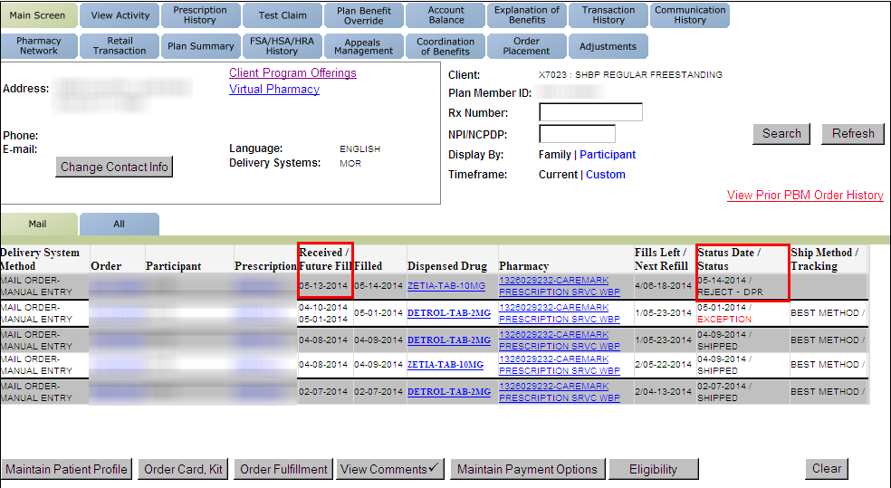
2 | View the Prescription Details for the prescription.  - The Rx Status will display Rejected DPR Hold if the Rx was placed on Prescriber Indefinite Hold.  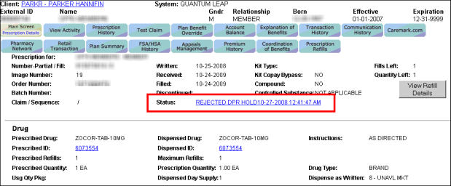
3 | - Additional clarification and/or a renewal is needed for the Rx, the pharmacy needs a response from the prescriber. (Do not advise the beneficiary to follow up with prescriber.)  - The prescription will be held until the prescriber provides us with the necessary information.  - I will need to transfer you to a team that can assist with contacting the prescriber directly on your behalf.  - If contact is made with the prescriber’s office but assistance cannot be provided at the time of the call, you will receive a follow up call within the next 2 business days, advising you of the status of the outreach to your prescriber.  - Please note, if you are enrolled in CMP alerts, even though we are reaching out to your prescriber, the system may generate messages to you in the meantime.  CCR Process Note:  CCR should transfer to the Senior Team Escalation Line. Refer to Med D - Senior Team - Delayed Prescriber Response/Prescriber Hold Process, MED D - When to Transfer Calls to the Senior Team and Basic Call Handling.

Top of the Document

Prescriber Hold Until

Perform the steps below:
Step | Action
1 | View the status of the prescription on the Main screen in PeopleSafe.  - It will display In Process (or Exception if the order due date has passed) when the Rx was placed on Prescriber Hold Until.  - A Future Fill date will also be displayed on the Main screen, but for Prescriber Hold Until Rx’s, it displays the expiration date of the Rx.  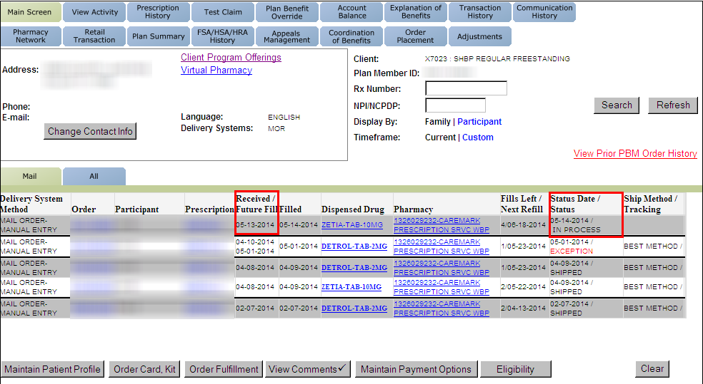
2 | View the Prescription Details for the prescription.  - The Rx status will display TRANSLATED - DIVERT if the Rx was placed on Prescriber Hold Until.  - The View Problems screen will display the conflict FFL – HOLD UNTIL PBR RESPONSE.  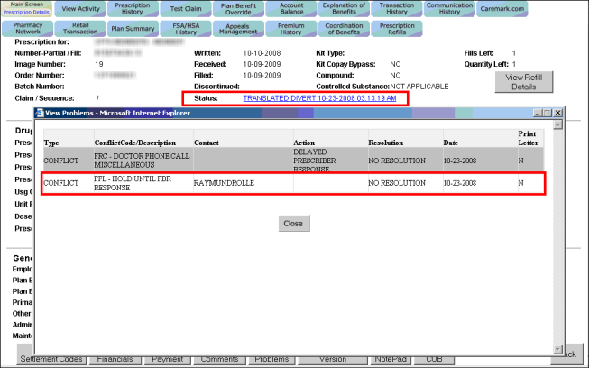
3 | - Additional clarification and/or a renewal is needed for the Rx, the pharmacy needs a response from the prescriber. (Do not advise the beneficiary to follow up with prescriber)  - The prescription will be held until the prescriber provides us with the necessary information.  - I will need to transfer you to a team that can assist with contacting the prescriber directly on your behalf.  - If contact is made with the prescriber’s office but assistance cannot be provided at the time of the call, you will receive a follow up call within the next 2 business days, advising you of the status of the outreach to your prescriber.  - Please note, if you are enrolled in CMP alerts, even though we are reaching out to your prescriber, the system may generate messages to you in the meantime.  CCR Process Note:  CCR should transfer to the Senior Team Escalation Line. Refer to Med D - Senior Team - Delayed Prescriber Response/Prescriber Hold Process, MED D - When to Transfer Calls to the Senior Team and Basic Call Handling.

Top of the Document

Inbound Call from Prescriber
If the prescriber or authorized prescriber representative calls to provide assistance regarding a Delayed Prescriber Response, the CCR will warm transfer the prescriber to the Physician Contact line at 1-800-459-1907. Hours of Operation are 7:30 am - 5:30 pm CST, Monday - Friday. If after hours, transfer to the Senior Team Escalation Line.

For Hawaiian Mail Order clients, warm transfer the prescriber to the Hawaii Clinical department at 1-877-418-4130, option 2. Hours of Operation are 8:00 am - 5:00 pm HST, Monday - Friday.

Top of the Document

Log Activity
Refer to the MED D - Call Documentation

Top of the Document

Resolution Time
Varies. The prescription will be processed once all required information/clarification is received from the prescriber.

Top of the Document

Related Documents
PBM Hold
Participant Hold
Parent SOP: CALL-0048: Medicare Part D Customer Care Call Center Requirements-CVS Caremark Part D Services, L.L.C.
Abbreviations/Definitions: Abbreviations / Definitions

Top of the Document
Not To Be Reproduced Or Disclosed to Others Without Prior Written Approval
ELECTRONIC DATA = OFFICIAL VERSION / PAPER COPY = INFORMATIONAL ONLY

